Miss Eastmond’s Copyright & Fair Use Guidelines
Use this when doing classroom projects
Photographs

You may use up to 5 images from the same photographer/illustrator.

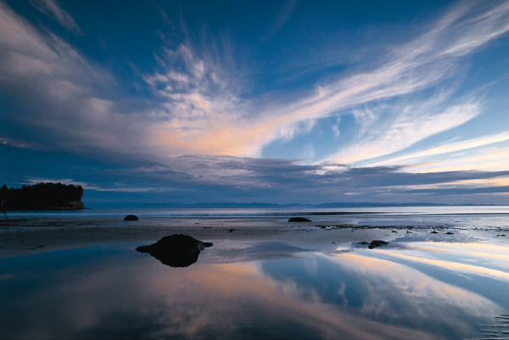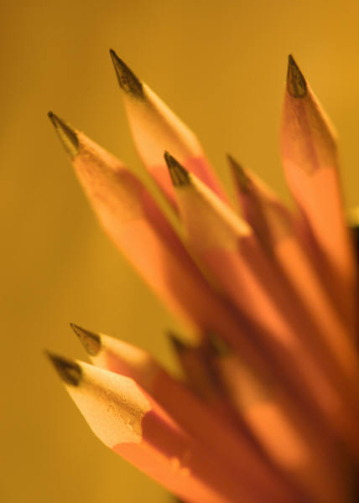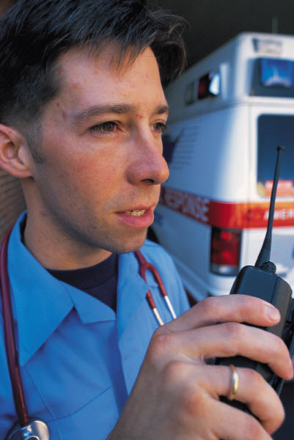

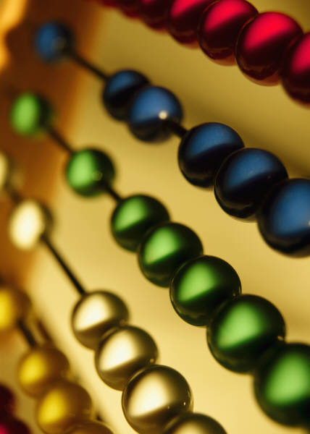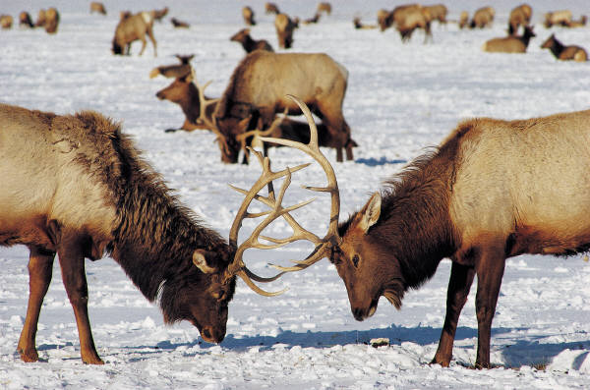

If you want to use more than 5, you must ask for permission and include a bibliography

Music
You may use up to 10% of a song,

If you want to use more, you MUST ask for permission and include a bibliography.
Video
You may use up to 10% or 3 minutes (whichever is less).

If you want to use more you must ask for permission and include a bibliography.

Text

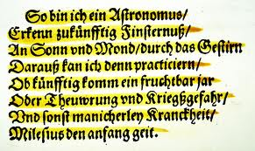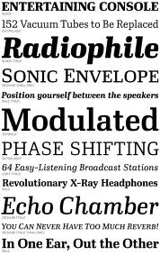
- Article, stories or essays less than 2500 words.
- 10% if work is over 2500 words or 1000 words (whichever is less)
- you can use a poem with less than 250 words.
- you can use up to 250 words form a poem with more than 2500 words
- one chart, picture or diagram per book or magazine
- two pages from a picture book

If you want to use more you must ask for permission and include a bibliography

