Internet Safety Lesson Plan for Fourth Grader Students
By Sierra Eastmond

Tentative Date of Lesson: Planned presentation to the fourth grade students at East Midvale Elementary the second week of school, before students start using the computers to do Success Maker

Objective: Students will score 80% or higher on an Internet Safety quiz demonstrating mastery. Students will know how to be safe on the Internet and will understand how fast information on the Internet travels.

Purpose: The purpose of this lesson is to teach students what the Internet is, and to help students understand how fast information can travel on the Internet.

Input:
Vocabulary: Internet, Internet Safety, Online, Cell Phone, Secret
Skills and Concepts:
- How to use Infuse Learning for Internet Safety Pre and Post Assessment
- Learn how to take notes (fill in the bank) from video presentations
- Learn how fast information spreads on the Internet using model clay

Anticipatory Set: Students will take a survey using Infuse Learning (pre-assessment) on what they know about Internet Safety and how fast information on the Internet travels.
Teacher Modeling/Guided Practice
- Model how to get on to Infuse Learning. Teacher will show students how to log on and log in using the pre-assigned quiz room number. The teacher will demonstrate how to take the pre-assessment on Infuse Learning, and then walk the students through logging on and logging in to the quiz. Teacher will also show how to submit the pre-assessment.
- After pre-assessment has been completed and submitted by all students, explain to students they are going to watch a video about the Internet. Students are going to watch two videos. The first is called “What is the Internet?” Explain to the students that as they watch the video, they are going to be taking notes, on the video that is playing. Pass out the first note page and read over the note page with the students. Explain that you will do the first few together, and you will pause the video, and make sure that everyone in the class go the first three blanks filled in.
- Play the first video. Pause the video throughout to model what information needs to be written down in the blanks, teacher may even want to switch over to the Doc Cam, so that students can visually see where the notes need to be taken. Model how to write down the correct words. Then guide students after each pause by discussing and asking students if they can share what they have learned and/or can think of more examples. At the end of the video, please review the fill in the blanks with students.
- Second video, “Mike-Tosis.” There will be no notes for this video.
Checking for Understanding:
Part 1: Play a stand up sit down game with the students. From the video notes pages, ask the students to stand up if they think the statement is true, or sit down if they think the statement is false. Ask questions and if the students thinks a statement that you are reading from the notes is true they will stand, if they think it is false they will sit. While doing this ask students to raise their hand if they want to explain why they chose true or false. State 5 to 10 statements from the video note sheets to check for understanding.
Part 2:
Pass out the How Fast Does Information Travel Sheet. Then get out the model clay. Start by giving one student a piece of the clay. Tell them that this piece of clay represents a piece of information, such as a secret you told a friend. Have the student rip off one small piece to keep. From the big chunk have the students divide the clay into two halves. Then have the student pass the two halves to two classmates. The two new students will repeat the process of keeping a little clay form themselves, halving the clay, and passing it on. This will continue until every student in the class has some clay. After this have the students complete Part 1 of the worksheet.
Answers are: 2,4,8, and 16

Independent Practice:
Assessment: Students will take the post-assessment quiz as a formative assessment. A summative assessment will consist of monitoring students as they complete part two if the Mike-Tosis worksheet.
Closure: To close the activity, students will sign the Netsafe Utah Pledge, and turn in the worksheet for you to look over

Additional Activities: Once all Internet permission slips have been received, students can use the computer lab and go online to review the above concepts. Students can play games and/or take additional quizzes to check their understanding.

Bibliography:

How Fast Does Information Travel. CDN. Netsmartz. Retrieved, June 27, 2013, from http://cdn.netsmartz.org/activitycards/IS_IM_MikeTosis.pdf
Internet safety pledge. Netsmartz. Retrieved, June 27, 2013, from http://www.netsmartz.org/resources .

Internet safety quiz. Missing Kids. Retrieved, June 27, 2013, from http://www.missingkids.com/missingkids/servlet/PageServlet?LanguageCountry=en_US&PageId=714.

Netsafe videos for kids. Netsafe Utah. Retrieved, June 27, 2013, from http://www.netsafeutah.org/kids/kids_videos.html.

NSTEEN Video, Mike-Tosis. Netsmartz. Retrieved June 27, 2013., from http://www.nsteens.org/videos/mike-tosis
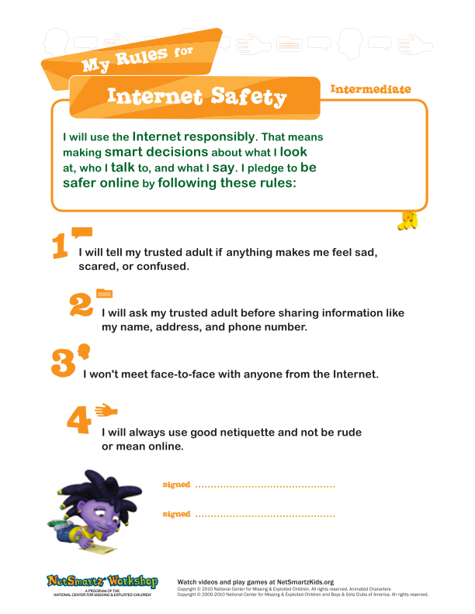
Name__________________ #___ Date___________

Internet Safety Notes

“What is the Internet” video notes

1. What are examples of the real world?
_______________________ ____________________
Can you think of two more places not shown in the video?
________________________ _____________________

2. The real world has ______________ who live in it.
________________________ ______________________
Can you think of two more not shown in the video?
________________________ _____________________
3. The Internet is NOT like the real world because it exists ONLY on ________________________. These are connected together all over the _______________________, so we can share ____________________________.
4. Since real people don’t _______________ inside computers, the Internet is not the real world. The Internet is a ______________ for people to get information.
5. What are some good things about the Internet?
_______________________ __________________
_______________________ __________________
_______________________ __________________
6. Use the circle to draw about how much of the Internet is for kids. The rest of the Internet might contain information not fun or safe for children.

Netsafe videos for kids, Retrieved, July 31, 2012, from Netsafe Utah website, http://www.netsafeutah.org/kids/kids_videos.html
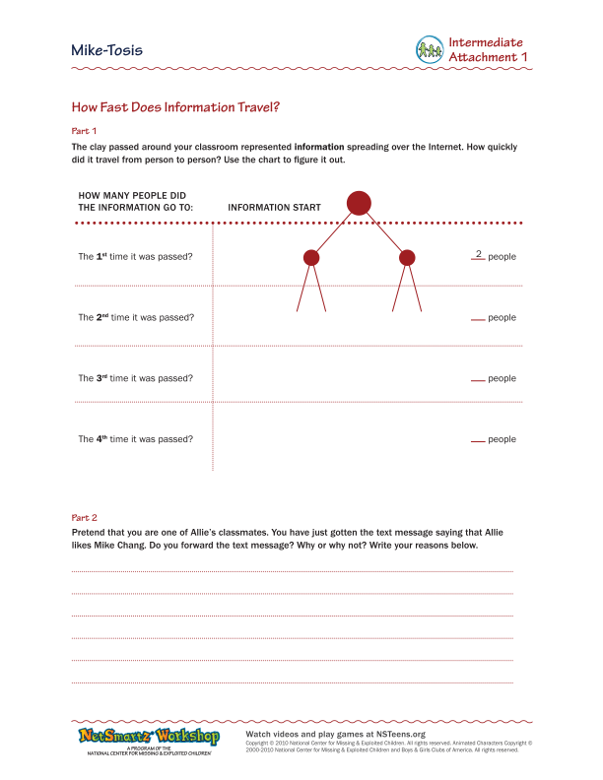
1. As I travel through "Cyberspace," information I should never give out to someone I meet online is
a. the names of my favorite books and movies.
b. my real name, address, telephone number, the school I attend, or my photograph.
c. the name of my pet.
2. If someone sends me an inappropriate message/material, I should
a. never reply to these messages and tell my parents, so that they can notify our online service provider.
b. keep it a secret.
c. reply to the message and ask the sender to stop sending me messages.
3. If someone I meet online asks me to keep a secret from my parents I should
a. keep the secret because they are my "cyber friend."
b. tell all of my friends, because it's hard for me to keep a secret.
c. tell my parents, because no one should ever ask me to keep secrets from my parents.
4. If someone is on my E-mail "buddy list," "friend list," or "contact list" and I only know that person online, he or she is
a. my friend and someone I can trust.
b. the person he or she claims to be.
c. someone I should be cautious about, because I don't know him or her well.
5. As I travel through "Cyberspace," I should never
a. take a break and have a snack.
b. use the Internet to help me with my homework.
c. agree to meet someone in person who I have met online.
6. The "CyberTipline" is
a. a cool, new video game.
b. my online source to report child-sexual exploitation.
c. a web site where I can find information about UFO's.

THIS QUIZ NEEDS TO BE LOADED INTO INFUSE LEARNING PRIOR TO THE LESSOn

